**Removal of failed track elements by direct modification of the session file**

This is quite complex to explain but not as complex to do.

1) Save a copy of the session file in case it becomes corrupted - very important!

2) Open the session file copy in Notepad++ (or another text editor that shows non-printing characters, Notepad ignores them so it won't work.)

3) Go right to the end of the file and find line "End of file at v2.13.0". This will be the last line for versions from v2.13.0 to v2.13.2 but later releases will add more data.

4) The data immediately above that line contains failure information as set out below (extracted from Notepad++ for a session file with failed points, signals and TSRs).

data above here is for all else

2 <-- number of failed points (0 if none), each listed with 3 integers and two floating point numbers - i.e. 5 lines each

2793 <-- position in memory of the failed point )

121 <-- original speed limit value for straight (or left hand if 'Y' point) track )

64 <-- original speed limit value for diverging (or right hand if 'Y' point) track ) failure data for one failed point

0.549930239560935 <-- time of failure in timetable days (this equates to a timetable time of 13:11:53) )

0.654791350672046 <-- repair time in timetable days (this equates to a timetable time of 15:42:53) )

2052

161

161

0.559707612242063

0.645818723353174

8 <-- number of failed signals (0 if none), each listed with one integer and 2 floating point numbers - i.e. 3 lines each

1124 <-- position in memory of the failed signal )

0.524011463547948 <-- time of failure in timetable days as above ) failure data for one failed signal

0.610122574659059 <-- repair time in timetable days as above )

1283

0.545729637676131

0.663090748787242

1414

0.548121883096327

0.625205216429661

2048

0.557821049754138

0.659209938643027

1721

0.563494730288666

0.593355841399777

1630

0.568253005715532

0.600197450159976

2514

0.571114579789436

0.662781246456103

802

0.571509984881131

0.605537762658908

7 <-- Number of TSRs (0 if none), each listed with 2 integers and 2 floating point numbers - i.e. 4 lines each

376 <-- position in memory of the track element with the TSR )

64 <-- original speed limit value for track element )

0.520352898721183 <-- time of failure in timetable days as above ) failure data for one TSR

0.595352898721183 <-- repair time in timetable days as above )

564

145

0.52712241260714

0.636844634829362

2894

121

0.548267890036085

0.622573445591641

1773

200

0.54867930207446

0.636873746518904

3344

121

0.554548642356976

0.599687531245864

3235

121

0.55802099189067

0.664965436335115

2613

64

0.578857670122387

0.654552114566832

End of file at v2.13.0

5) In order to identify the specific failed element it is necessary to find its position in memory, and to do that requires an undocumented feature in the program (there for my own benefit when debugging new versions but available to everyone). Open the program and load the session in question. Then hold down both the 'Control' and 'Alt' keys together, and while they are depressed press the '3' key. This should bring up the development panel below the railway as shown:-

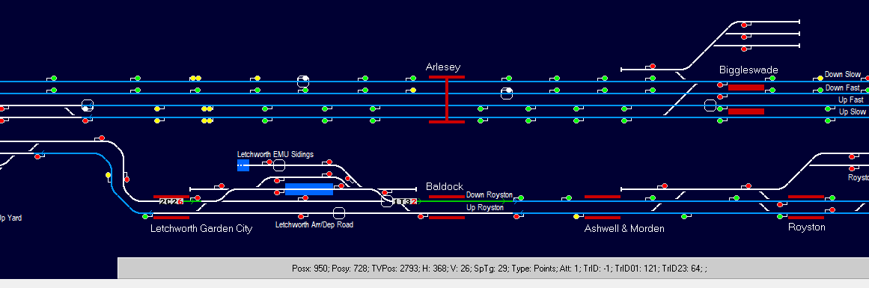

The information in the panel depends on where the mouse is. This is shown with the mouse hovering over the failed point just behind train 1T32 (the mouse itself isn't shown in screenshots). The position in memory appears after 'TVPos:' (track vector position) - here 2793, which will be seen as the first of the two failed points in the listing above.

6) To remove this from the session file (the copy) change its repair time to zero and resave the file. After reloading this session the point will be repaired immediately on operating the program and the program will take care of all the other required restoration actions.

7) Press 'Control-Alt-3' again to remove the development panel.

8) The same procedure can also be used for signals and TSRs, and more than one can be removed by these means at the same time if required.

*****************************